General testing update : 22/10/2016

Testing report from Local HOST

1.Teacher applied for a job; “Instrument you can teach” doesn’t let user to submit a form

SEEMS TO ME A VADILADTION ERROR

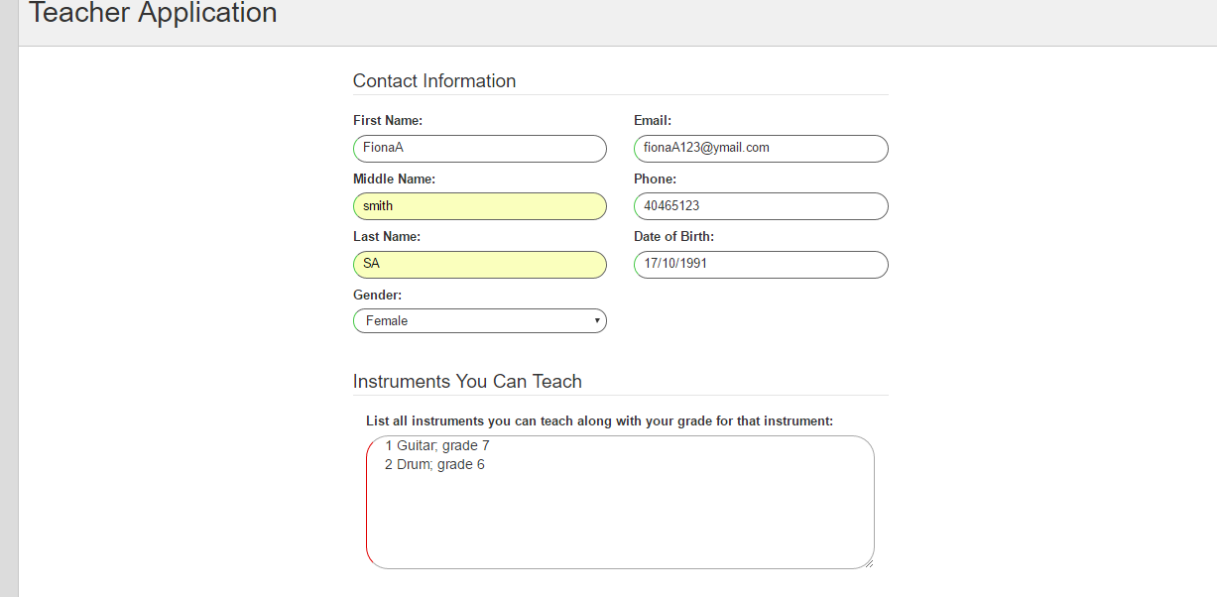

2. **Teachers Registration** through **manager account**; not working unable to submit the form after filled out all the information. NO VALIDATION ERROR

“Unable to Submit” the form